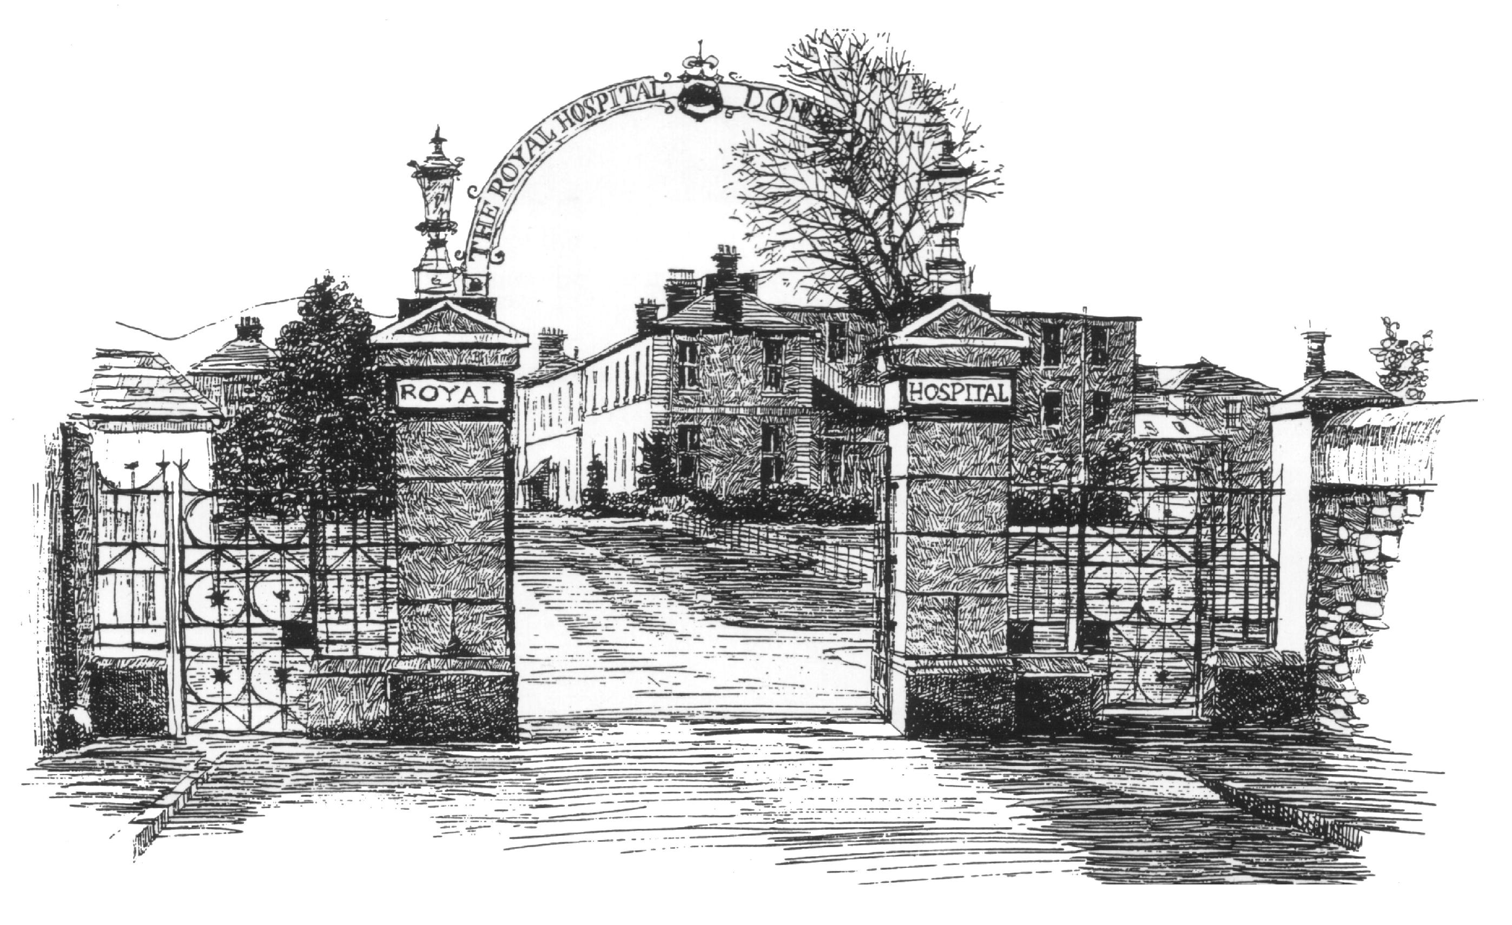
The Royal Hospital Donnybrook

Morehampton Road, Dublin 4 Email: ty@rhd.ie

Transition Year Application Form
Personal Details

Students Name: ____________________ Phone: ____________________
DOB:
Students Address: ________________________________________________________________________
________________________________________________________________________________________
Email: __________________________________________________________________________________
Parent /Guardian Name: ___________________ ___ _______________Ph:___________________________
School Address: ___________________________ _________________Ph: _________________________
Transition Year Coordinator: __________________ Phone: _______________________________________
Transition Year Coordinator Email: ______________

Placement Details:
3 days a week, Tuesday till Thursday 10am - 4pm
In which week are you interested? 26th-28th November 2024 or 25th-27th March 2025

Please attach a copy of your school insurance and Garda Vetting Clearance (if over 16 years old)
Why are you interested in participating in our TY programme?

_________________________________________________________________________________________________________________________________________________________________________________________________________________________________________________________________________________________________________________

Have you any special needs or medical requirements that you feel we should know about?

Signed (Student) ____________________________________ Date: _______________

